KUTC JOINT PROJECT INTERIM ASSESSMENT REPORT
Assessment Period 26/09/2020– 15/08/2021
Combined Report (KU + External Research Partners)

Project Details
Budget Code: | 8474000259
KUTC Reference | KUTC01
Full Project Title: | Development of solid electrolytes for harsh environment batteries
Principal Investigator: | Daniel Choi
Co-Investigators:
Research Staff: | Prerna Chaturvedi
PhD Student(s):
MSc Student(s):
Project Start Date: | 26/11/2019 | Project End Date: | 25/11/2022
External Collaborator | Hae Jin Kim (KBSI in South Korea)
KU Budget Allocation | (AED) 1,101,750 for 3 years
Partner Budget Allocation | (AED) 1,102,000 for 3 years
Total Project Budget | (AED) 2,203,750 for 3 years

Total Project Budget per Fiscal Year (AED)
2019 | 2020 | 2021 | 2022
31,750 | 367,250 | 367,250 | 335,500

Actual Expenditure to Date (AED)
2019 | 2020 | 2021 | 2022
4,520 | 35,000

Summary of Project & Deliverables to date (min. 2 / max. 3 pages) + Gantt Chart (Plan vs Progress)

In this time period, we have demonstrated a pouch cell with MWCNT nanocomposite-based electrodes and gel-like polymer electrolytes. We also developed a process of stacking 12 cells inside a pouch cell (pilot size of pouch cell: 85mm x 55mm) in order for a single pouch cell to possess capacity of 150 mAh. Figure 1 shows a image showing a pouch cell (capacity of about 150 mAh) fabricated as a result of stacking 12 cells.

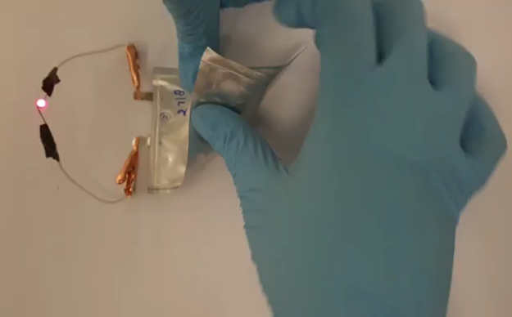

Figure 1. An image showing a pouch cell (capacity of about 150 mAh) fabricated as a result of stacking 12 cells.
Under this project, our efforts will be focused on ‘Scaling-up’ for fabrication of large-size pouch cell in order to increase ‘Loading Level of Battery Active Materials’, which will lead to increase capacity of each pouch cell to 2Ah/cell.

Tasks/Milestones | Year 1 |  |  |  | Year 2 |  |  |  | Year 3
Task 1: Development of LITFSI in PYR14TFSI ionic liquid based gel polymer electrolyte (KU)
Progress
Task 2: Development of Li superionic conductor solid electrolytes (KBSI/ YHK, JGK, MYS)
Progress
Task 3: Development of porous CNT nanocomposite by freeze casting method (KU)
Progress
Task 4: Testing half-cells (KBSI/WGH,JGK)
Task 5: Modelling and simulation of the solid electrolytes - SEI formation (KBSI/HJK)
Progress
Task 6: Thermal analysis of solid electrolytes (KU)
Progress
Task 7: Fabrication of full-cell batteries (pouch cell) – single cell (KU/KBSI/WGH,YHK)
Progress
Task 8: Fabrication of full-cell batteries (pouch cell) – multiple cells, stacked batteries (KU/KBSI/WGH)
Task 9: Testing/demonstration of full-cell batteries (pouch cell) as a prototype for EV battery (KU/KBSI/WGH)
Task 10: Harsh environmental tests of prototype full cell batteries (KBSI/WGH, JGK)

Challenges Faced & Mitigation Plan (min. 1 page)

The main motivation of the work is to prepare solid polymer electrolyte with high conductivity and good compatibility with CNT based electrode materials. We have developed a processes for fabrication of semi-solid electrolytes with high ionic conductivity of about 10⁻³-10⁻⁴ S/cm, good adhesion with cathode nanocoposites and anode nanocomposites based on CNTs, good control of thickness of solid electrolytes. Figure 2 shows a photo of the ‘Gel-like’ solid electrolyte film and SEM image of it.

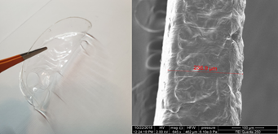

Figure 2: A photo (left) and a cross-sectional SEM image (right) of the ‘Gel-like’ solid electrolyte film.

We are also in the middle of developing solid electrolytes (‘Not gel-like’). Solid polymer electrolytes represent the ultimate in terms of desirable properties for batteries because they can offer an all-solid-state construction, simplicity of manufacture, a wide variety of shapes and sizes, and a higher energy density. No corrosive or explosive liquids can leak out, and internal short-circuits are less likely, hence greater safety. Al doped LLZO (Li6.25 Al0.25 La3Zr2O12) solid electrolytes are being developed based on solid state reaction.
.

Summary of External Research Partner Contributions to Date (min. 500 words per Partner)

KBSI have been developing ‘Super-ion based solid electrolytes’. Their electrochemical performance shows about 90% capacity retention during 100 cycles of charge and discharge, and about 69% capacity retention even after 1500 bending tests. In addition, the stacking technique was applied to internal composite electrodes for improving the energy density of all-solid-state batteries. Dr. Kim’s group is also continuously developing novel solid electrolyte and next-generation all-solid-state batteries which are closely related to this project.

** Only outputs specifically referencing this KUTC award by way of acknowledgment of funding will be considered an award output **
Project Output Data – Specific to this Project during the report period
Journal Publications (Include full reference details including DOI)
KU Sole Authors | P. Chaturvedi, A. Kanagaraj, D. Choi, “LiCrTiO4-MWCNT self-standing electrodes as high performance anode for flexible Li-ion batteries”, Materials Letters, 304, 130665, 2021
KU + Project Partners (Joint) Authors | P. Chaturvedi, A. Kanagaraj, A. Alhammadi, H. Alshibli and D. Choi, “Fabrication of PVDF-HFP based microporous membranes by the tape-casting method as a separator for flexible Li-ion batteries”, Bulletin of Materials Science, 44, 2, 161, 2021.
Project Partners Sole Authors

Conference & Workshop Presentations (Include presentation title, event name, month/year)
KU Sole Presenter
KU + Project Partners (Joint) Presenters
Project Partners Sole Presenter

Invention Disclosures – Files/Granted Patents (filing reference / patent number)
KU Sole Inventor
KU + Project Partners (Joint) Inventors
Project Partners Sole Inventor
Other Project Outputs (optional)

